SQL expression: select T.name, S.course_id from instructor as T, teaches as S where T.ID= S.ID;
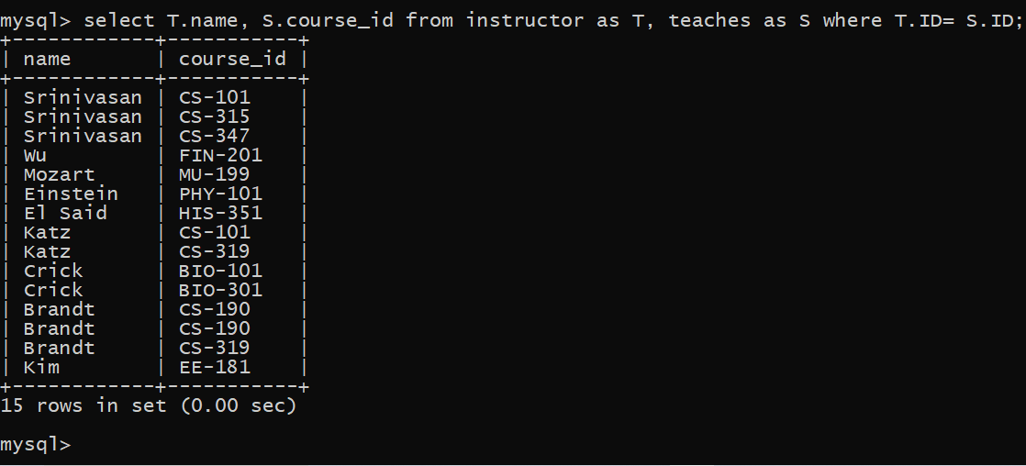
Finding the names of all instructors whose salary is greater than at least one instructor in the Physics department.
SQL expression: select distinct T.name from instructor as T, instructor as S where T.salary > S.salary and S.dept_name = 'Biology'; 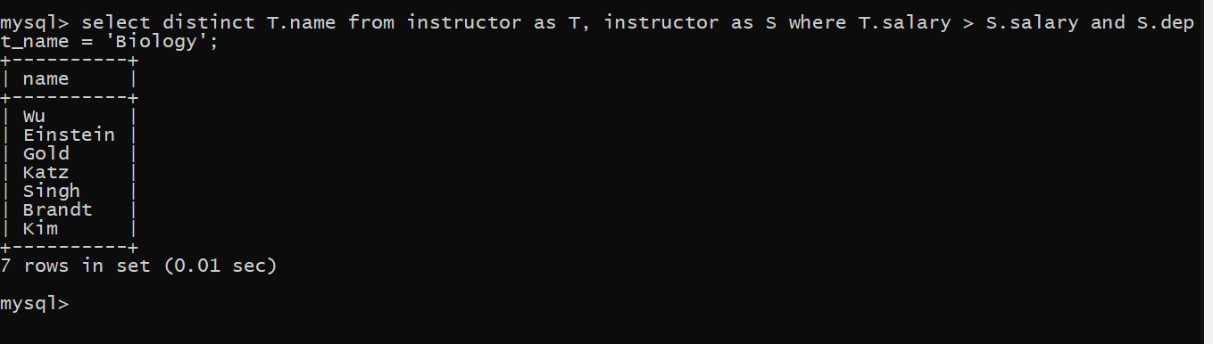
Finding the names of all departments whose building name includes the substring '1’.
SQL expression: select dept_name from department where building like '%watson%';
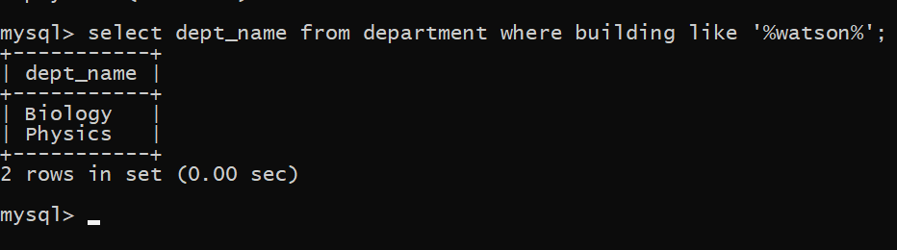

The asterisk symbol ‘*’ can be used in the select clause to denote all attributes. Herer is and example:
SQL expression: select instructor.* from instructor, teaches where instructor.ID= teaches.ID;
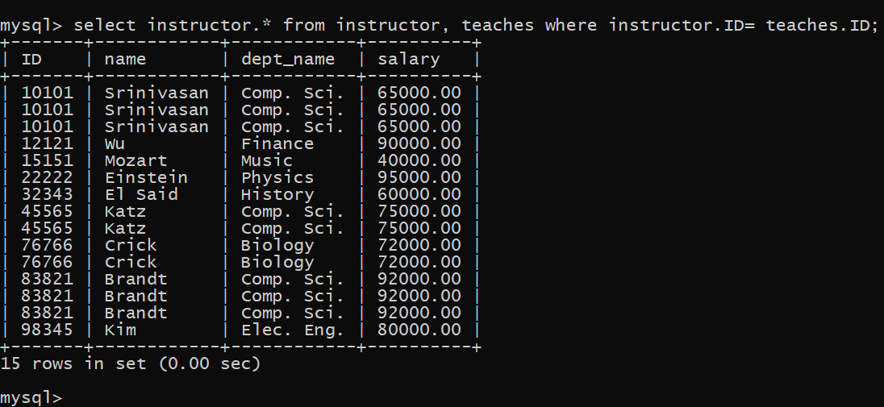

The order by clause causes the tuples in the result of a query to appear in sorted order. Here is an example:
SQL expression: select name from instructor where dept_name = ' Physics' order by name;
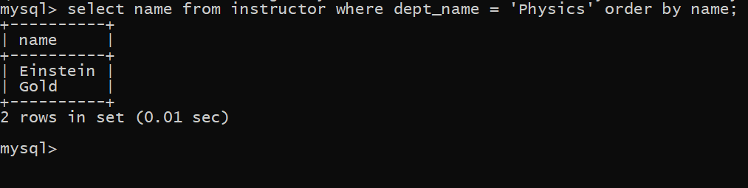
We wish to list the entire instructor relation in descending order of salary. If several instructors have the same salary, we order them in ascending order by name.
SQL expression: select * from instructor order by salary desc, name asc;
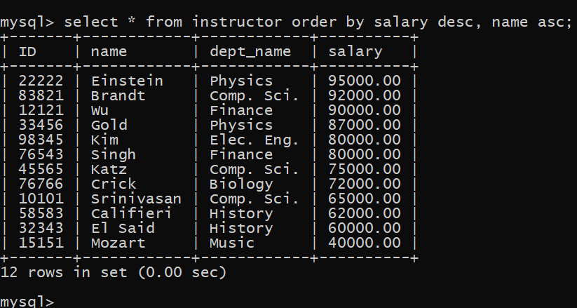
If we wish to find the names of instructors with salary amounts between 30,000 and 45,000. The query will be like this:
SQL expression: select name from instructor where salary between 30000 and 80000;
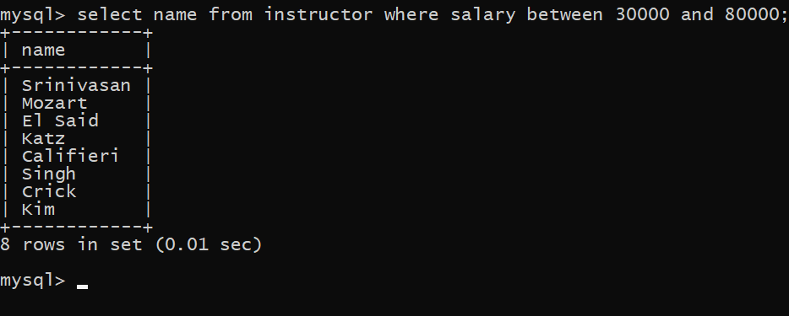
Finding all courses taught in the Fall 2017 semester but not in the Spring 2018 semester.
SQL expression: (select course_id from section where semester = 'Fall' and year= 2017) except (select course_id from section where semester = 'Spring' and year= 2018);
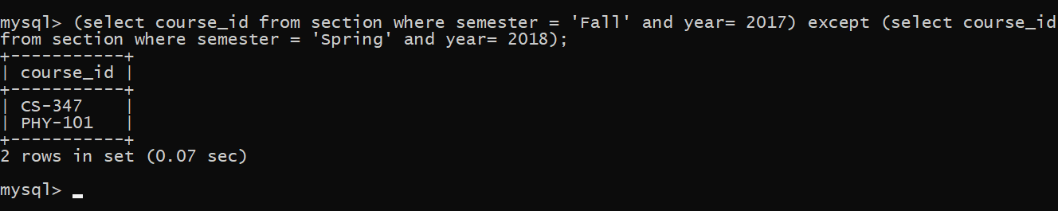
Finding the set of all courses taught in the Fall 2018 semester.
SQL expression: select course_id from section where semester = ‘Fall' and year= 2017;
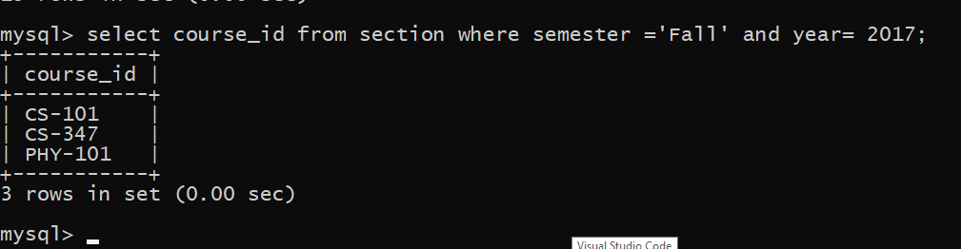
Finding the set of all courses taught either in Fall 2017 or in Spring 2018, or both.
SQL expression: (select course_id from section where semester = 'Fall' and year= 2017) union (select course_id from section where semester = 'Spring' and year= 2018);
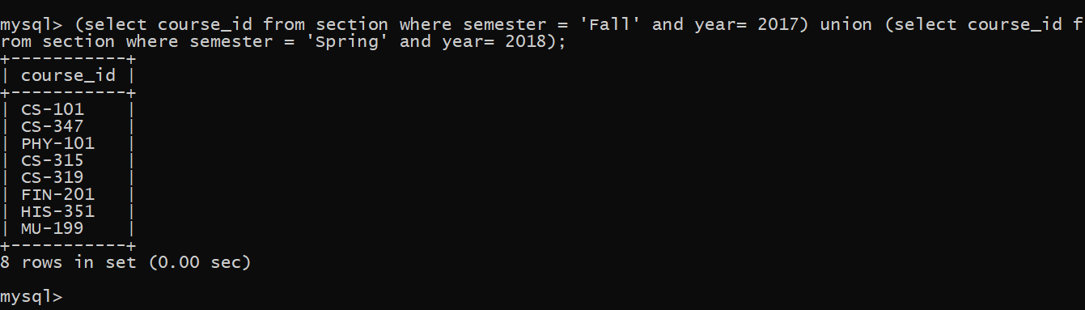

Finding the set of all courses taught in both the Fall 2017 and Spring 2018.
SQL expression: (select course_id from section where semester = 'Fall' and year= 2017) intersect (select course_id from section where semester = ‘Spring' and year= 2018);
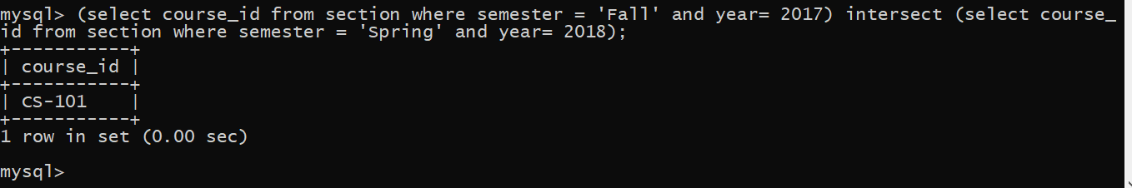
Finding all instructors who appear in the instructor relation with null values for salary.
SQL expression: select name from instructor where salary is null;
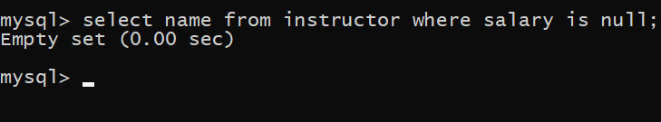

Finding the average salary of instructors in the ICT department.
SQL expression: select avg (salary) from instructor where dept_name = 'comp .sci.';
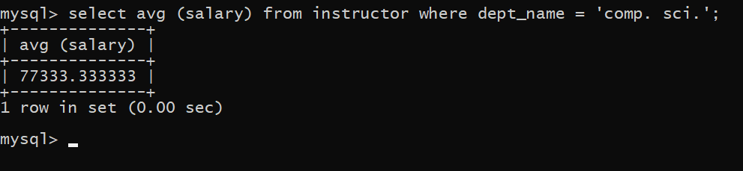

Finding the average salary in each department.
SQL expression: select dept_name, avg (salary) as avg_salary from instructor group by dept name;
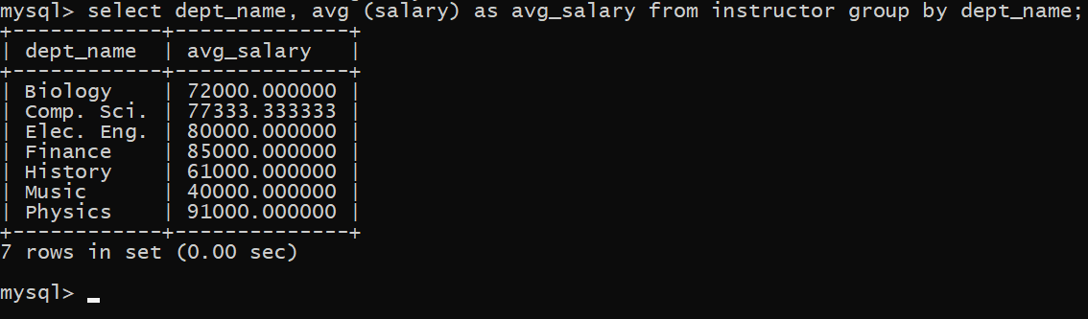
Find the average salary of all instructors.
SQL expression: select avg (salary) from instructor;

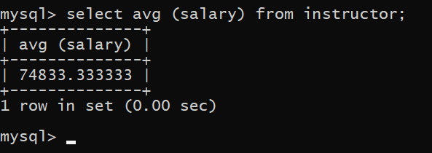

Finding how many teachers taught in Fall 2018 semester.
SQL expression: select count(distinct ID) from teaches where semester = 'Fall' and year = 2017;
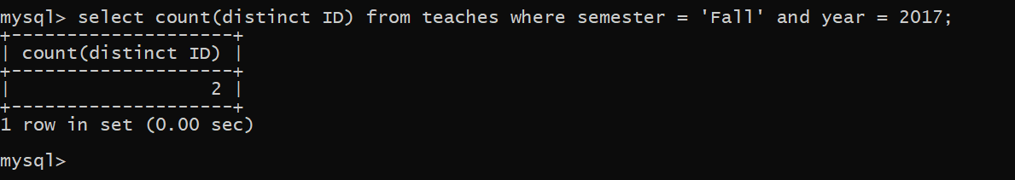
Finding the number of tuples in the course relation.
SQL expression: select count(*) from course;
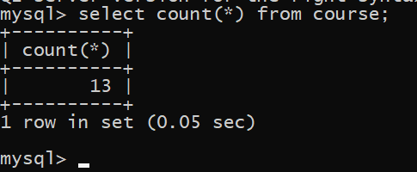
Finding the total salary.
SQL expression: select sum(salary) from instructor;

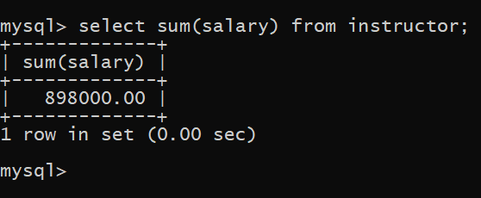

Finding the department name and average salary where the average salary of the instructors is more than 31,000.
SQL expression: select dept_name,avg(salary) as avg_salary from instructor group by dept_name having avg(salary)>31000;
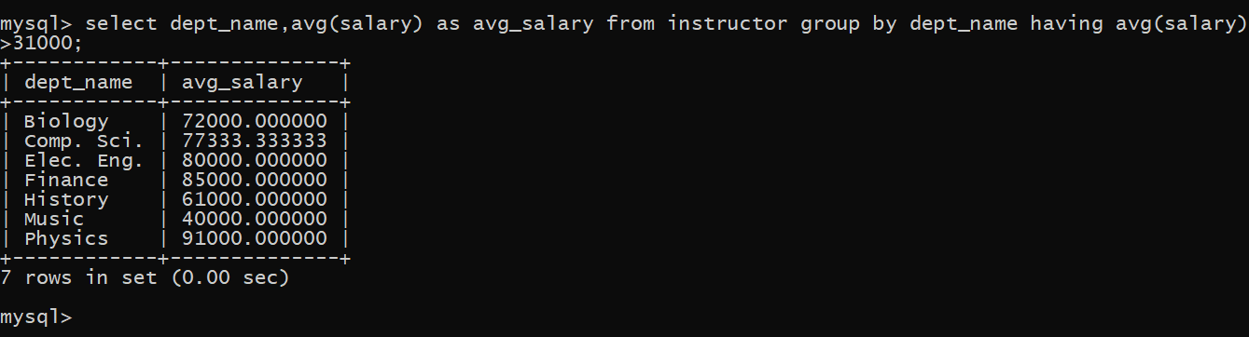

We wish to know the names of instructors whose names are neither “
Mozeret” nor “Einstein”.
SQL expression: select distinct name from instructor where name not in ('Mozert’, 'Einstein');
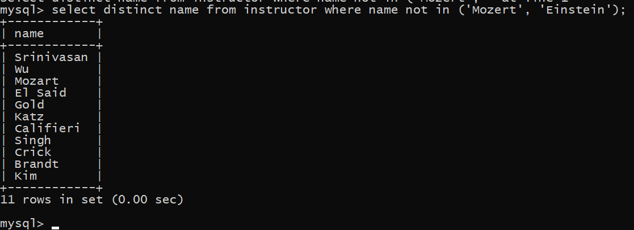

Discussion: From the above query we can easily find our desired attributes. We can command different types of queries to find any type of data set that we are looking for.

